|  |  |
| --- | --- |
| Name | Umar Hayyat |
| Roll No | 2019-EE-360 |

**Lab 2**

**Introduction to Variable declaration and initialization,Comment and Casting**

**Objectives:**

In this lab,

* I will learn about variable declaration and initialization.
* I will learn about comment in Java.
* I will learn how we casting of a data type.

**Task 1:**

Declare and initialize a variable. Now re-initialize and re-declare the same variable again see what happen? And Comment on it.

**Code:**

public class NewClass {

public static void main(String[] args){

//declare vriable x of integer type

int x;

//initialze the value of variable x

x=5;

System.out.println(x);

/* Try to re-declare it give error which show that

variable x already declared.You cannot declare it again

*/

x=7; //re-initialize the value of variable x

System.out.println(x);

//re-declare a variable x

int x;

}

}

**Output:**

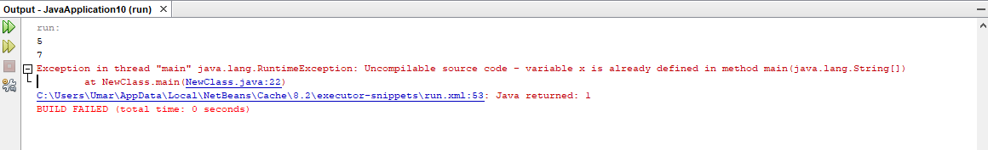

**Comment:**

Re-initialization is allowed in Java but re-declaration is not allowed . When I re-initialize the variable x in above code or program then 5 is replaced by 7. Now the value of x is 7 and its previous value 3 is garbage value. When I re-declare the variable x then it give error because we cannot declare the same variable again.

**Task 2:**

Initialize the variable and change its type by using implicit and explicit casting. Comment on it.

**Code:**

public class NewClass {

public static void main(String[] args) {

//implicit casting

/* On L.H.S declare x as float

On R.H.S (int/int=int) 5/2=2

which is then converted to 2.0 by compiler

*/

float x=5/2;

System.out.println("x="+x);

//Explicit Casting

/* On L.H.S declare y as integer

On R.H.S (int)2.5 which is converted by compiler inyo 2. Compiler remove decimals

*/

int y=(int)2.5;

System.out.println("y="+y);

}

}

**Output:**

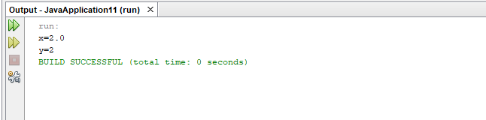

**Comment:**

In **implicit casting**, the variable is indirectly converted into other data type. In the above code numerator and denominator both are integer. In Java, when we divide int value with int value answer will be int. So, 5/2 is equal to 2. As I declared x as a float variable so value is 3.0.

In **explicit casting**, the variable is directly converted into other data type. In the above code when I write (int)2.5 then compiler automatically remove the decimal and convert it into integer .

**Conclusion:**

In this lab, I learnt it is very necessary to declare a variable in java . in python we don’t need to declare or specify the data type of variable. In Java , first we declare a variable name an d its data type then we initialize the variable. I also learnt how we write a comment in java. Comment can be used to provide the information about variables. Comments are the statement that are not executed by compiler. I also learnt about casting. Casting is a process of converting one data type into other data type. I learnt about two types of casting implicit and explicit casting and practically performed the task in lab.